Climate change due to agricultural factors- analysis based on world bank data

GitHub repo link: <https://github.com/sahana248/climate_change.git>

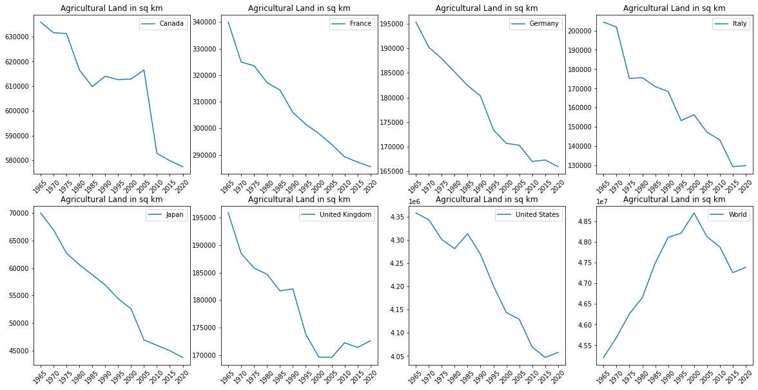 For this analysis a group of countries known as the G7 nations were taken (Canada, France, Germany, Italy, Japan, UK, USA). G7 nations are the seven leading industrial countries in the world (it was called G8 until the removal of Russia in the year 2014). The following factors were considered to understand the impact of climate change: Urban Population, Fertilizer consumption, Agricultural NO2 emission, Agricultural methane emission, agriculture land area.

|  |  |
| --- | --- |
| **Country Name** | **Change in land area** |
| Canada | 18067.74 |
| France | 17752.12 |
| Germany | 10047.67 |
| Italy | 23597.34 |
| Japan | 8755.49 |
| United Kingdom | 8576.22 |
| United States | 119625.00 |
| World | 1140801.00 |

Table 1: Change in Agricultural area

Figure 2: Agricultural Land in sq. km between 1965- 2020 in G7 nations

When we compare the area of agricultural land in the above-mentioned countries, we can note that there is an overall decrease in the numbers for all the G7 nations, whereas the numbers have increased all over the world. The table shows the average change in area each year starting from 1965 to 2020.

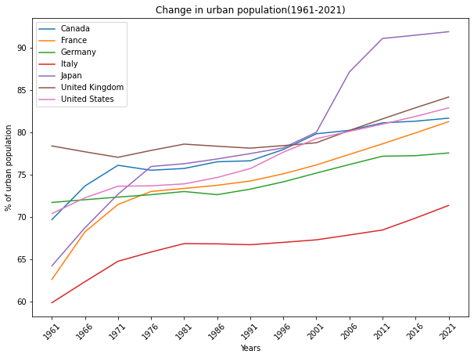

Figure 2: Percent of Urban population between 1961- 2021

From the graph plotted between the percentage of urban population from 1961 to 2021, we can observe that there is an overall increase in the percentage of Urban population. Increase in the urban population is an important indicator to understand the development of a country. Here we can see that in Japan the percentage is nearing 100, in Canada, Italy and US there is a change of 11 to 12%, whereas Germany and UK have the least change of 6 to 7 %. From figure 1 and 2, we can understand that due to economic growth and urbanisation in these countries the agricultural land area has declined and the urban population has increased

Figure 3 and 4 are the amount of NO2 and methane emitted due to agricultural activities. Both nitrous oxide and methane are greenhouse gases responsible for climate change. Interestingly, agricultural emissions of NO2 in the U.S. account for nearly 80 percent of the total human emissions of this gas. Nitrous oxide is mainly produced to excessive usage of fertilisers and improper management of manure. On the other hand, agricultural methane emission contributes nearly 32% of human-caused methane emission. This is produced mainly from manure and gastroenteric releases of livestock. From the graphs we can understand that the amount of methane and NO2 emission has not changed much over the decades. There is slight drop in the amount of methane produced in all the countries, except for Canada, where the numbers slightly increased during the 2000’s and again dropped back in the 2010’s.

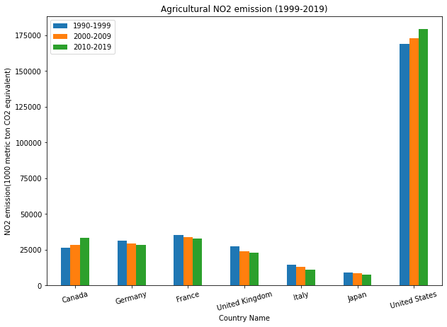 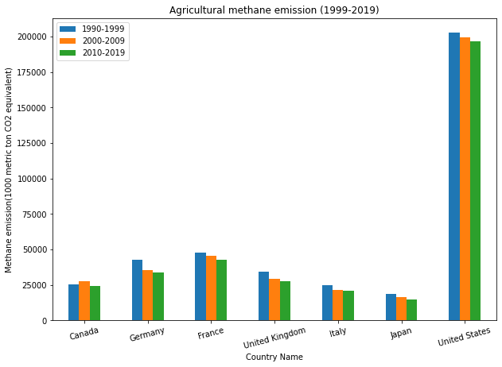

Figure 3: Agricultural NO2 emission between 1990- 2019

Figure 4: Agricultural methaneemission between 1990- 2019

From figure 3, it can be seen that the amount of nitrous oxide produced has dropped in all the European countries and Japan. But there is a slight increase in the amount of methane emitted, both in Canada and the US over the years. Despite the drop in agricultural area (figure 1), we can still see that there is no significant drop in the amount of methane or nitrous oxide produced in all the countries considered here.

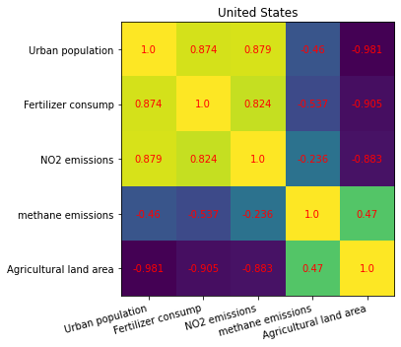

Figure 5: Heatmap of United states

From the heat map of United states (figure 5), we can see that change in Urban population is somewhat related to nitrous oxide emission and fertiliser consumption. Whereas the agricultural land area is inversely correlated to the urban population. From this it can be inferred that increase in urban population paired with decrease in agriculture land area has resulted in the increase in consumption of fertilisers thus increasing the production of NO2.

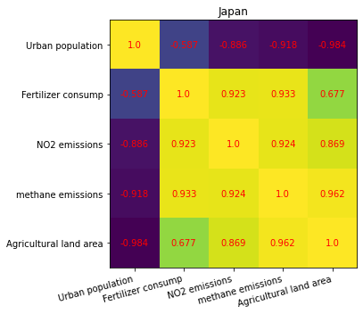

Figure 6: Heatmap of Japan

From the heat map of Japan (figure 6), we can see that similar to US the increase in urban population is inversely affecting the agricultural land area, also the methane and NO2 emission are being inversely affected by population. Also, the consumption of fertilisers and agricultural land area are positively correlated to the emission of the greenhouse gases. The consumption of fertilisers doesn’t seem to have any effect on the growth of urban population.

References

<https://civileats.com/2019/09/19/the-greenhouse-gas-no-ones-talking-about-nitrous-oxide-on-farms-explained/>

<https://www.unep.org/news-and-stories/story/methane-emissions-are-driving-climate-change-heres-how-reduce-them>

<https://data.worldbank.org/>